- How many regions are there in Italy?
- 21
- 22
- 20
- 19
- What is the smallest region in Italy?
- Basilicata
- Sicily
- Valle D’Aosta
- Lazio
- What’s the name of the big sea that is the union of all the seas that surround Italy? 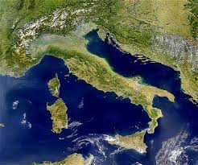
- Black sea
- Mediterranean sea
- Baltic sea
- Tyrrhenian sea
- When did Italy become part of the European Union? 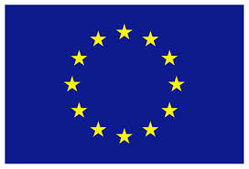
- 1961
- 1952
- 2002
- 1946

- Which is the European Capital of Culture 2019?
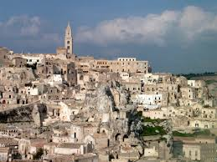
- Milan
- Matera
- Lecce
- Rome
- Which artist painted “The Gioconda”?
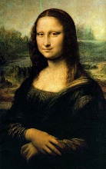
- Giotto
- Modigliani
- Raffaello
- Leonardo da Vinci
- Which are the two mountain ranges in Italy?
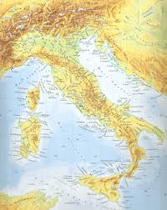
- The Alps and the Pyrenees
- The Alps and the Apennines
- The Urals and the Pyrenees
- Hymalaya and k2
- What’s the name of the President of the Italian Republic?
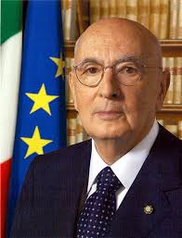
- Matteo Renzi
- Giorgio Armani
- Giorgio Napolitano
- Mario Draghi
- What is the longest river in Italy?
- Tevere
- Po
- Arno
- Basento
- What is the typical carnival mask of Naples?
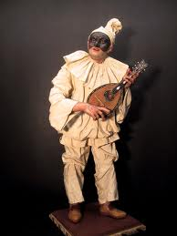
- Pantalone
- Arlecchino
- Pulcinella
- Colombina

