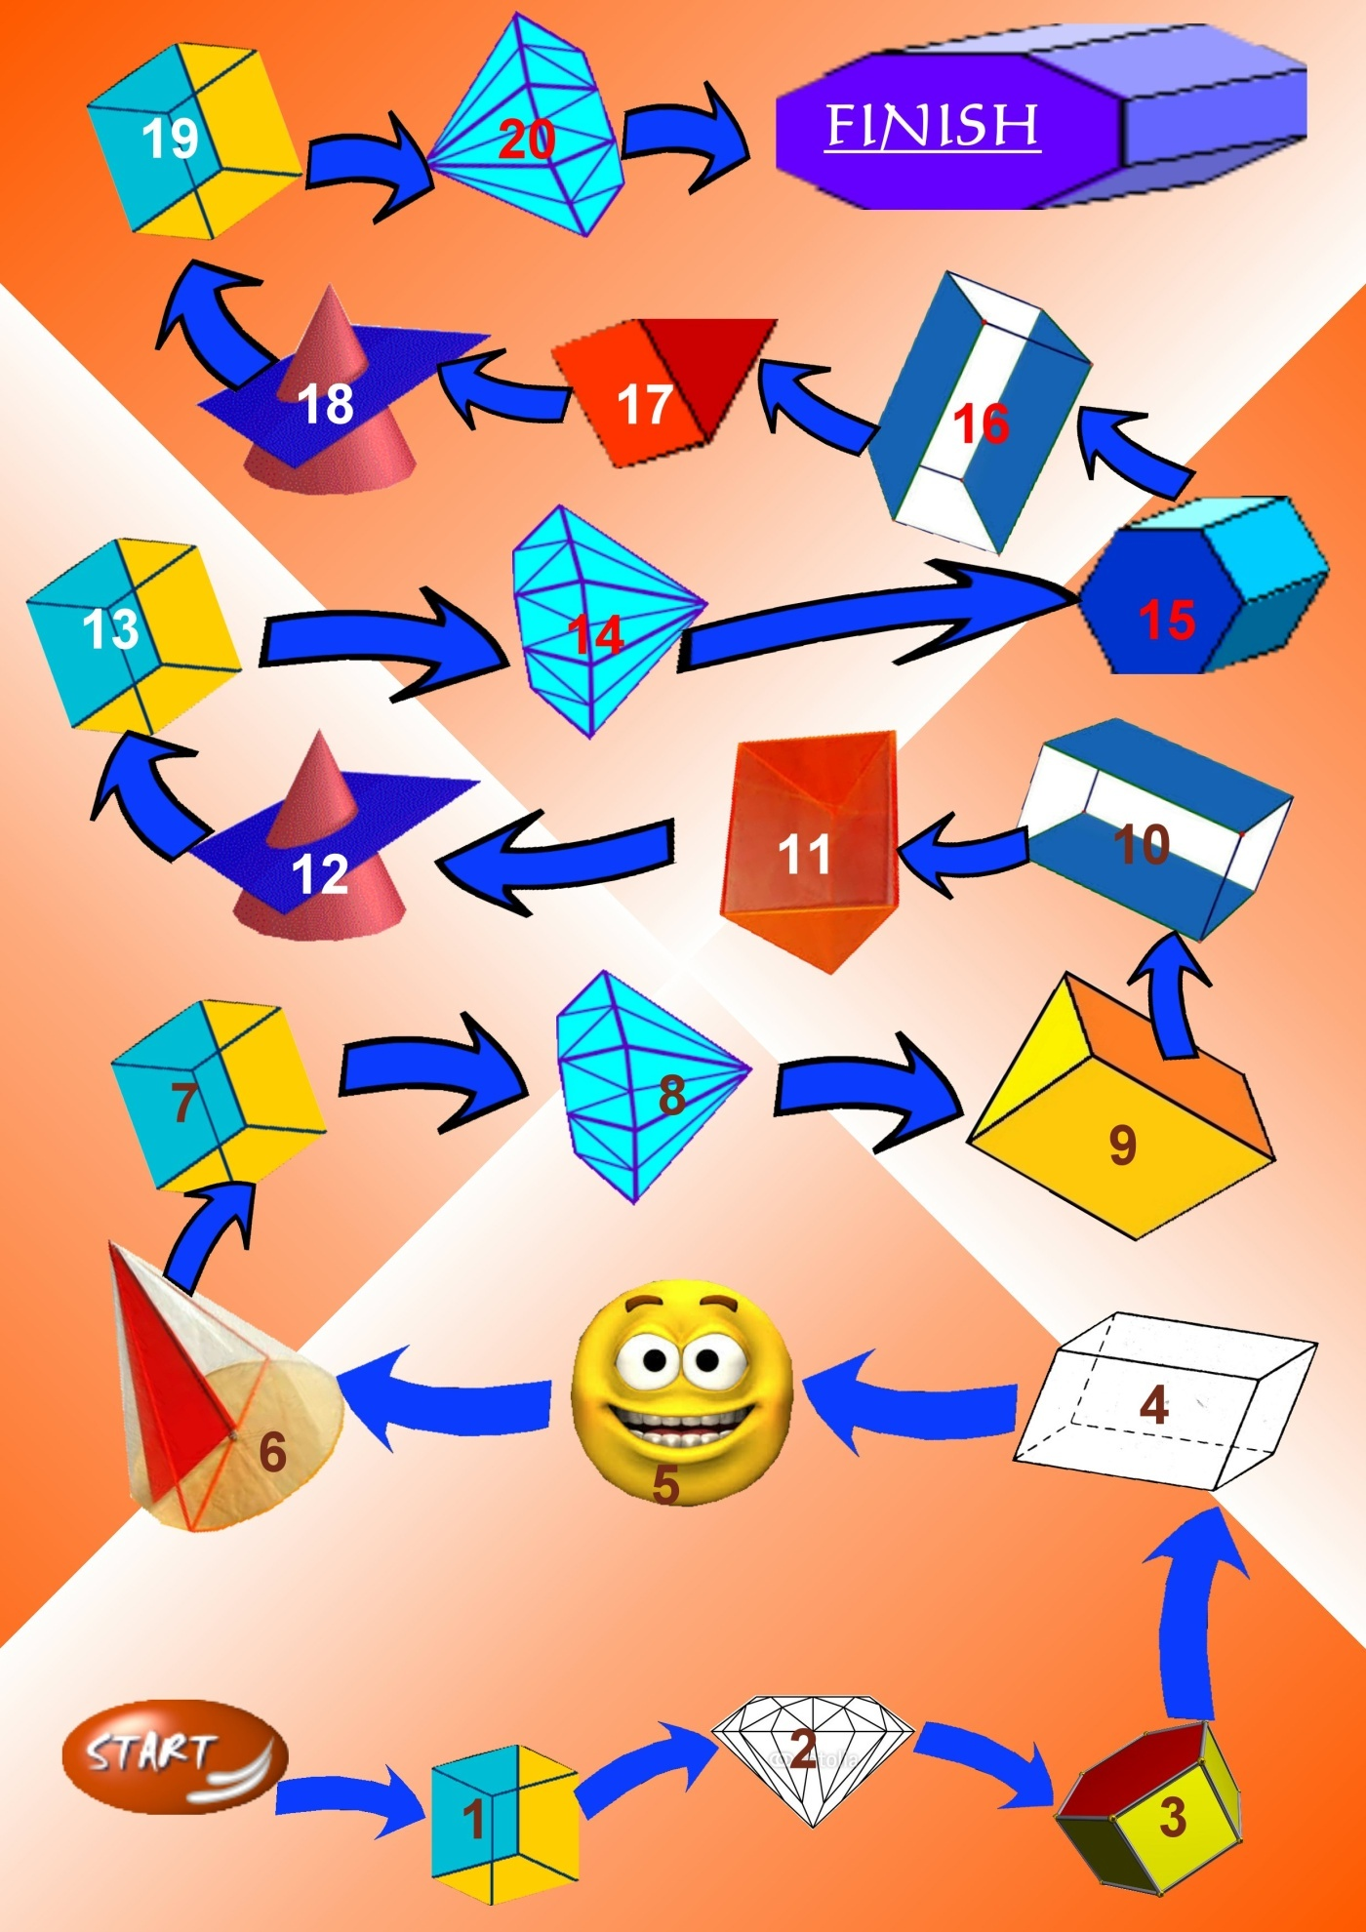

Geometric shapes and calculus

Instructions:
The game can be played by 2 up to 4 contestants. The players should roll the dice. The game will be started by the player that obtained a bigger number. Every player should roll the dice once and move forward with as many positions as the dice shows. Arriving to one point the player should read and fulfill the task requested to that number.
Requests:
- You arrived in The Cube Land. You may go forward with as many positions as the result to:
$$\left[\left(48+151\right)-199\right]+1^{36}$$
- You are in Diamond Country. The mayor of Diamond city ask you to help him to find all the natural divisors of 38. If you found its all you may go forward with one more step, otherwise you will wait one round.
- You are in the forest of Geometric shapes. You can advance one step if you answer correctly to the question: “ is 137 a prime number?”, otherwise you will wait one round.
- Bravo! You arrived in the Rectangular Mountains. You may go forward two steps if you find the correct result to :
$$\left\{\left[{\left(2^{2}∙2^{3}\right)}^{1}+4^{1}∙4^{1}\right]-48\right\}+1$$
Otherwise you should go back with 3 steps.
- It seems that you are starting to go better and better. In order to advance with two steps find the supplement of an angle that measures 133$°$. If you are wrong, you should wait two round.
- Now you can help the mayor of Pyramids city to find the answer to the question:”how many sides has a trapezoid?”. If your answer is helpful you may advance two steps, if you don’t you should stay one round.
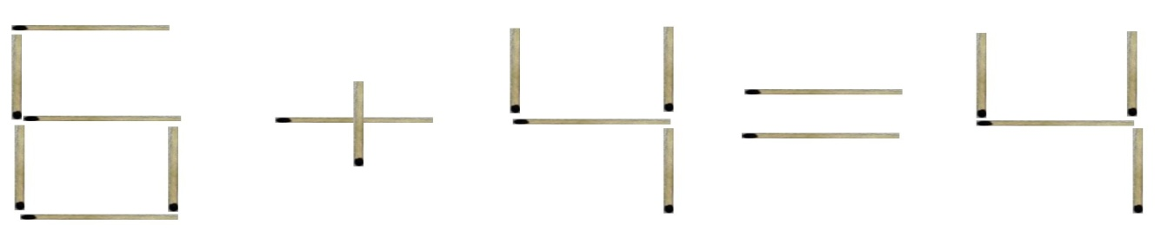
- You are lost in Cubic Desert, your escape is the correct answer to the next challenge:
Move one matchstick for the affirmation to be true:

- Welcome to Diamonds Mine. In order to advance one step, verify if the inequality is true or false:
$\frac{15}{17}<0,\left(8\right)$.
- To advance 3 steps name the positions of two coplanar lines.
- You arrived on the Space objects beach. To cross the ocean you should name the first 12 prime numbers.
- To cross the Cubic jungle you should say how many vertex three cubes have?
- To cross Pyramidal Maze you should find the smallest common multiple and the biggest common divisor for the next numbers:
$$A=2^{3}∙5^{1}∙3^{2}$$
$B=3^{1}∙2^{5}∙7^{1}$.
- An inhabitant from Cubic city asks:
“How should a geometric plane be referred?” If you don’t know the answer you should stay another round.
- You are again in Diamond Country. The president ask you to help him answer to the next question: Are two congruent angles having different measures?
- To advance one step you should say angles classifications.
- You can escape from the swam if you say :
  - two subunit fractions
  - two eqiunitary fractions
  - two supraunitary fractions
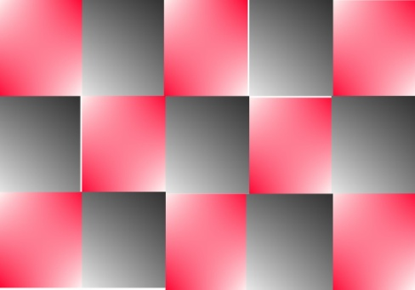
- You are stuck between moving sands, to get out you should find out if the fractions are equivalents:
$\frac{18}{24}; \frac{3}{2}$.
- The Pyramid Pharaoh ask you to say what fraction of an integer the red part of drawing represent.
- The king Cube orders you to bring the fraction to irreducible form: $\frac{12}{15}$.
- To become the Great Emperor of Mathematics you should find the last digit of $4^{100}$.

